Customer-Support Intent Classification
A Duplicate-Aware Evaluation of Neural Text Models
Week 7 Technical Report
Bishwadeep Rai
Westcliff University
TECH 405: Artificial Neural Network and Deep Learning
Professor Aashish Dhakal
October 18, 2026
Project: AI-Based Smart Queue & Time Management System

2. Introduction and Problem Statement
Customer-support requests arrive as free-form text and must be directed to a service function such as order cancellation, refund handling, delivery information, or account recovery. Manual triage can add handling time and route a request to an unsuitable queue. This Assignment 6 project examines whether a model can infer a support intent from the text of an incoming request and provide a candidate routing label.
Formally, this is supervised, single-label multiclass text classification. For an input instruction x, the model predicts one label y from a fixed set of 27 intent classes. The notebook uses only the `instruction` field as model input and `intent` as the target. The task is a prototype evaluation on a public hybrid synthetic dataset—not a deployed queue-routing system or a test of wait time, service-level performance, or customer outcomes.
The central methodological concern was repeated text: several source rows contain identical instructions after case and whitespace normalization. If copies of the same request appeared in both training and testing, metrics could reward memorized phrases rather than generalization. The implementation therefore groups normalized duplicates before the stratified split and checks group separation.

3. Project Objectives and Classification Task
- Inspect the source file and characterize class balance, missingness, repeated text, and instruction length.
- Predict the labeled `intent` from `instruction` only, among the dataset's 27 classes.
- Compare an order-insensitive TF-IDF feed-forward MLP with a token-sequence PyTorch LSTM.
- Prevent exact case/whitespace duplicate requests from crossing train, validation, and test partitions.
- Fit text representations on training data only and reserve the grouped test partition for final evaluation.
- Report accuracy, macro precision, macro recall, macro F1, multiclass ROC-AUC, per-intent metrics, and confusion matrices.
- Interpret results in light of synthetic/automatic labeling and limits on external validity.
The majority-class baseline predicts the most frequent training intent for every test request. With 27 near-balanced classes, it provides a useful low-information reference; it is not expected to be a strong routing model.

4. Dataset Description and Source
The notebook loads the Bitext Customer Service Tagged Training Dataset from the Hugging Face dataset repository. The project artifact records 26,872 examples and five selected fields: `flags`, `instruction`, `category`, `intent`, and `response`. Only `instruction` is passed to the classifiers; `intent` is the prediction target. `category`, `response`, and `flags` are excluded from model features because they can directly reveal or shortcut the target and/or represent information not available as the intended input.
The dataset card describes the corpus as hybrid synthetic data generated for customer service/virtual-assistant use and declares the CDLA-Sharing-1.0 license. The notebook downloads the CSV to a user cache rather than committing the raw data. Dataset license and card terms should be reviewed before redistribution (Bitext, n.d.).
Property | Verified project value
Dataset | Bitext Customer Service Tagged Training Dataset
Rows / selected columns | 26,872 / 5
Target | `intent` (27 nominal classes)
Model input | `instruction` text only
Intent supports | 950–1000 source rows per class
Dataset source | https://huggingface.co/datasets/bitext/Bitext-customer-support-llm-chatbot-training-dataset
Raw-data storage | Downloaded to a local cache; not stored in this repository

The source fields and their use in this project are:
Source field | Role in the experiment
`flags` | Audited as source metadata; not used as a model input.
`instruction` | Sole text predictor provided to the classifiers.
`category` | Audited metadata; excluded from model input to avoid a target shortcut.
`intent` | Ground-truth target label; encoded into 27 class IDs.
`response` | Associated response text; excluded because it is not available at routing time and could reveal the label.

Target classes observed in the saved results:
Intent class | Intent class | Intent class
cancel_order | contact_human_agent | payment_issue
change_order | create_account | place_order
change_shipping_address | delete_account | recover_password
check_cancellation_fee | delivery_options | registration_problems
check_invoice | delivery_period | review
check_payment_methods | edit_account | set_up_shipping_address
check_refund_policy | get_invoice | switch_account
complaint | get_refund | track_order
contact_customer_service | newsletter_subscription | track_refund

5. Exploratory Data Analysis
The audit found 26,872 rows, 27 intents, and no missing or blank values in any of the five inspected source fields. The smallest and largest intent classes contain 950 and 1000 examples, respectively; the target is therefore close to balanced rather than dominated by one class. That makes macro-averaged metrics appropriate for comparing performance across intents.
Instruction length averages 8.69 whitespace-separated words; median 9; interquartile range 7–11; observed range 1–16. Median length varies by intent (the notebook records medians from 6 to 11 words). The EDA is descriptive and does not establish that request length causes or independently predicts an intent.
Case- and whitespace-normalization produced 24,274 unique instruction groups. Among them, 1,187 groups are repeated, adding 2,598 duplicate rows beyond one representative per group. The notebook checks that normalized duplicates do not map to conflicting intent labels. This evidence motivated grouped rather than row-wise splitting.
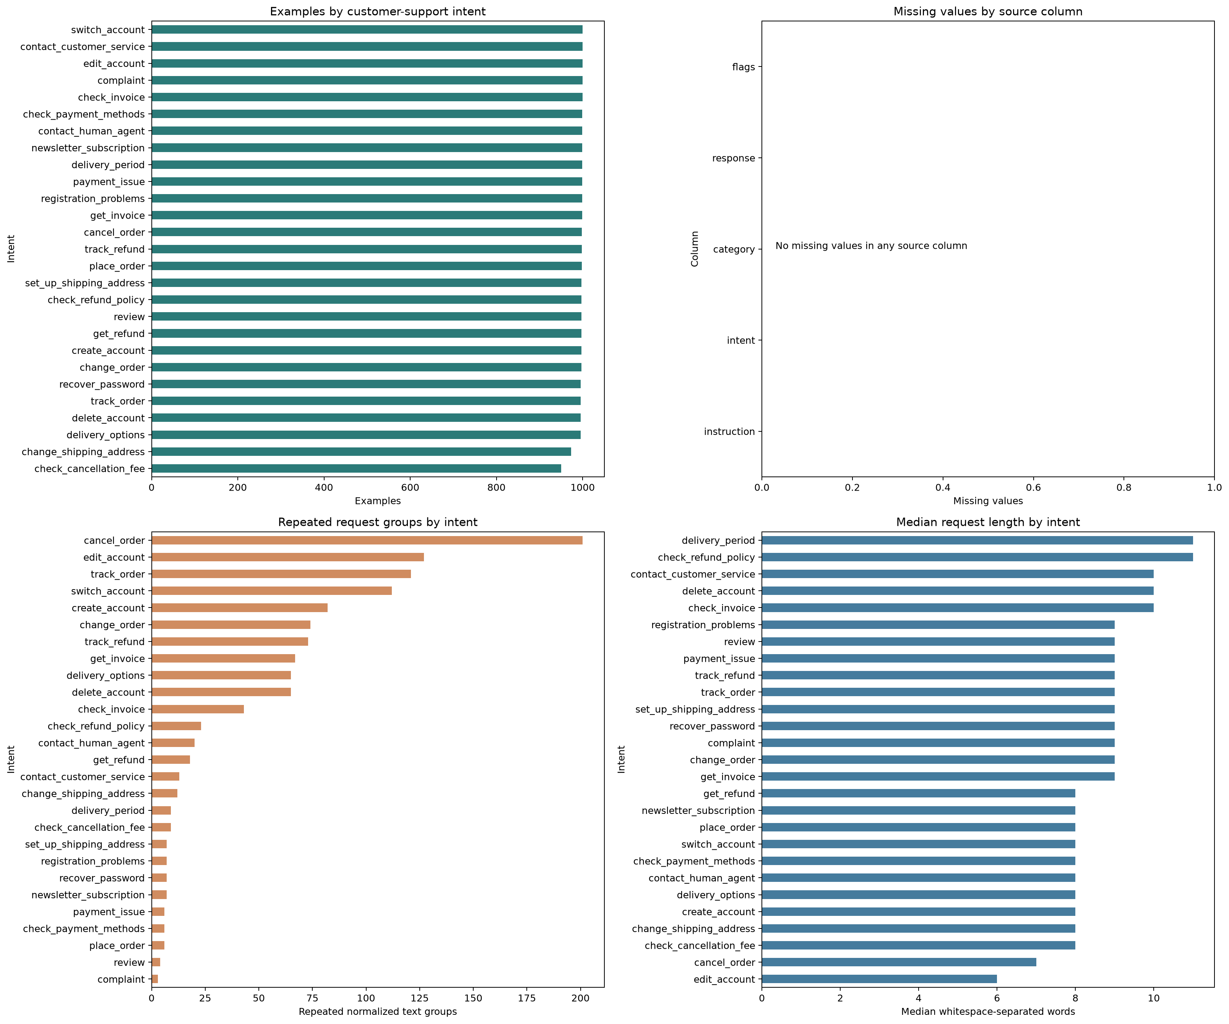
Figure 1. Intent support, missingness, repeated normalized requests, and instruction length
Note. This four-panel figure is the saved exploratory output from the executed notebook. Near-balanced label counts do not rule out linguistic or dataset-construction bias.

6. Machine-Learning Development Pipeline
Figure 2 represents the actual Assignment 6 process. The dataset is first inspected; normalized duplicates are identified and assigned as groups before splitting. Training text alone is used to learn TF-IDF and token vocabularies. The MLP and LSTM are trained as parallel alternatives, selected/checkpointed using validation macro F1, and evaluated on the same held-out test groups. Predictions are converted to 27-class outputs for metrics and error analysis.
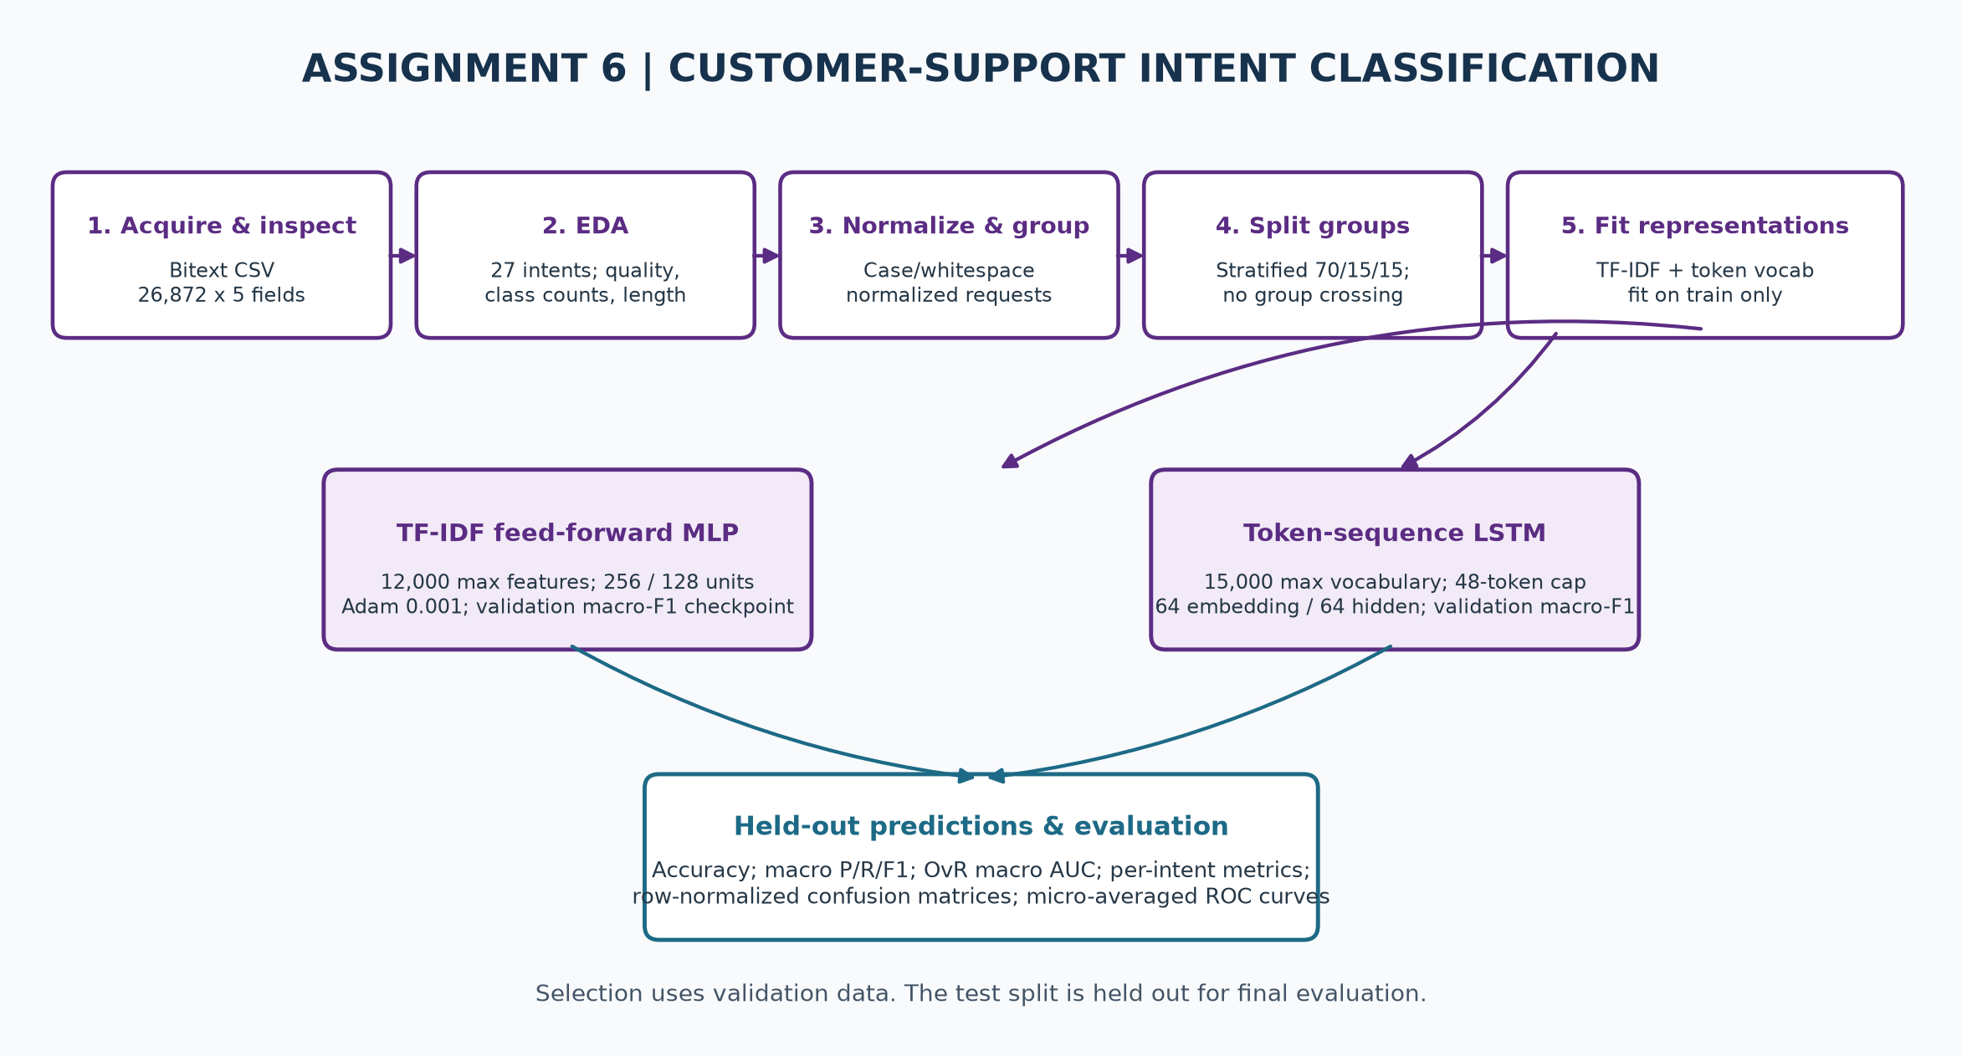
Figure 2. Assignment 6 intent-classification pipeline implemented in the notebook
Note. The diagram is a process illustration generated from verified notebook settings; it is not a model output. The displayed result charts that follow are saved experimental outputs.
Pipeline stage | Purpose in this implementation
Acquire / inspect | Load the public CSV; verify schema, dimensions, labels, missingness, and source values.
EDA | Describe intent counts, repeated normalized instructions, and request lengths.
Normalize / group | Create case-folded, whitespace-collapsed keys; validate consistent intent per duplicate group.
Split | Stratify unique groups into train/validation/test to prevent normalized copies crossing partitions.
Represent text | Fit TF-IDF and the token vocabulary on training rows only; transform the other partitions.
Train / select | Train two distinct neural architectures; retain validation-selected checkpoints.
Predict / evaluate | Generate held-out class probabilities and labels; calculate metrics, confusion matrices, and ROC curves.
Interpret | Compare results and document corpus, leakage, and external-validity limits.

7. Data Preprocessing and Train/Test Splitting
Text is normalized for duplicate detection by Unicode-aware case-folding, collapsing runs of whitespace to a single space, and trimming. A factorized group ID represents each normalized instruction. Before a split is accepted, group summaries verify that each group has exactly one intent label; conflicting labels raise an explicit error. This normalization is used to establish groups, while the actual original instruction strings remain the model inputs.
The split uses random seed 42. Unique instruction groups are first split into 70% training and 30% held-out groups with stratification by intent. The held-out 30% is split equally into validation and test, yielding approximate 70/15/15 proportions. Rows are mapped back to those groups; disjointness assertions check that no group ID is shared between partitions. Every intent is asserted present in all three partitions.
Partition | Rows | Normalized groups | Approx. row share | Per-intent support
Train | 18,831 | 16,991 | 70.1% | 664–718
Validation | 4,010 | 3,641 | 14.9% | 138–160
Test | 4,031 | 3,642 | 15.0% | 135–159

For the MLP, `TfidfVectorizer.fit_transform` is applied to training text and the fitted vectorizer only transforms validation and test text. For the LSTM, the token-frequency vocabulary is built by iterating over training indices only; unseen tokens map to the unknown token. This prevents the held-out vocabulary from influencing learned text representations. The model target encoder maps labels to indices; the split is stratified on intent labels.
Duplicate grouping addresses exact duplicates under the specified normalization. It does not demonstrate that paraphrases, shared templates, or other semantically similar synthetic requests are independent across partitions.

8. Model Architectures and Implementation

8.1 TF-IDF feed-forward MLP
The MLP is a fast lexical baseline that converts each instruction into a sparse TF-IDF vector of unigrams and bigrams. The vectorizer lowercases text, retains up to 12,000 features, removes terms with document frequency below two, and uses sublinear term frequency (scikit-learn developers, n.d.). The feed-forward network has dense layers of 256 and 128 units with ReLU activations and dropout 0.35 and 0.25; the output has 27 logits. Training uses Adam (learning rate 0.001, weight decay 0.0001) and cross-entropy. Sparse rows are converted to dense batches of 256 for neural-network updates. Training is capped at 10 epochs with patience 2, retaining the checkpoint with best validation macro F1.

8.2 PyTorch token LSTM
The LSTM models token sequences and can represent word-order context. Tokenization uses a lowercase regular expression for letters, digits, and apostrophes. The vocabulary contains at most 15,000 training-derived tokens plus padding and unknown tokens. Sequences are truncated/padded to 48 tokens. An embedding layer maps token IDs into 64-dimensional vectors; a one-layer LSTM has hidden size 64, followed by dropout 0.30 and a 27-logit linear output. Packed sequences use the true instruction lengths. Training uses Adam at 0.001, batch size 128, cross-entropy, up to 8 epochs, and patience 2 on validation macro F1 (PyTorch contributors, n.d.).

8.3 Baseline
The baseline selects the majority label from training labels and predicts it for every test example. This provides a reference for the class-balanced task and helps check that the neural models improve beyond a constant prediction.
Notebook runtime output records PyTorch 2.14.1+cpu, CPU execution, and seed 42. No GPU timing, training-time comparison, or deployment latency benchmark is recorded in the saved artifacts.

9. Intermediate Development Steps and Outputs
Step | Recorded output
Source load | 26,872 rows x five source fields; 27 classes.
Quality checks | Zero missing values and zero blank instructions/labels after trimming in the five audited columns.
Duplicate audit | 24,274 normalized groups; 1,187 repeated groups; 2,598 additional duplicate rows; labels agree within groups.
Partitioning | Train 18,831/16,991 rows/groups; validation 4,010/3,641; test 4,031/3,642.
MLP training history | 6 epochs; training loss 2.6557 to 0.0279; best validation macro F1 0.9943 at epoch 4.
LSTM training history | 8 epochs; training loss 2.0016 to 0.0263; best validation macro F1 0.9918 at epoch 8.
Held-out predictions | 4,031 requests; MLP correct 3,999, errors 32; LSTM correct 3,984, errors 47.

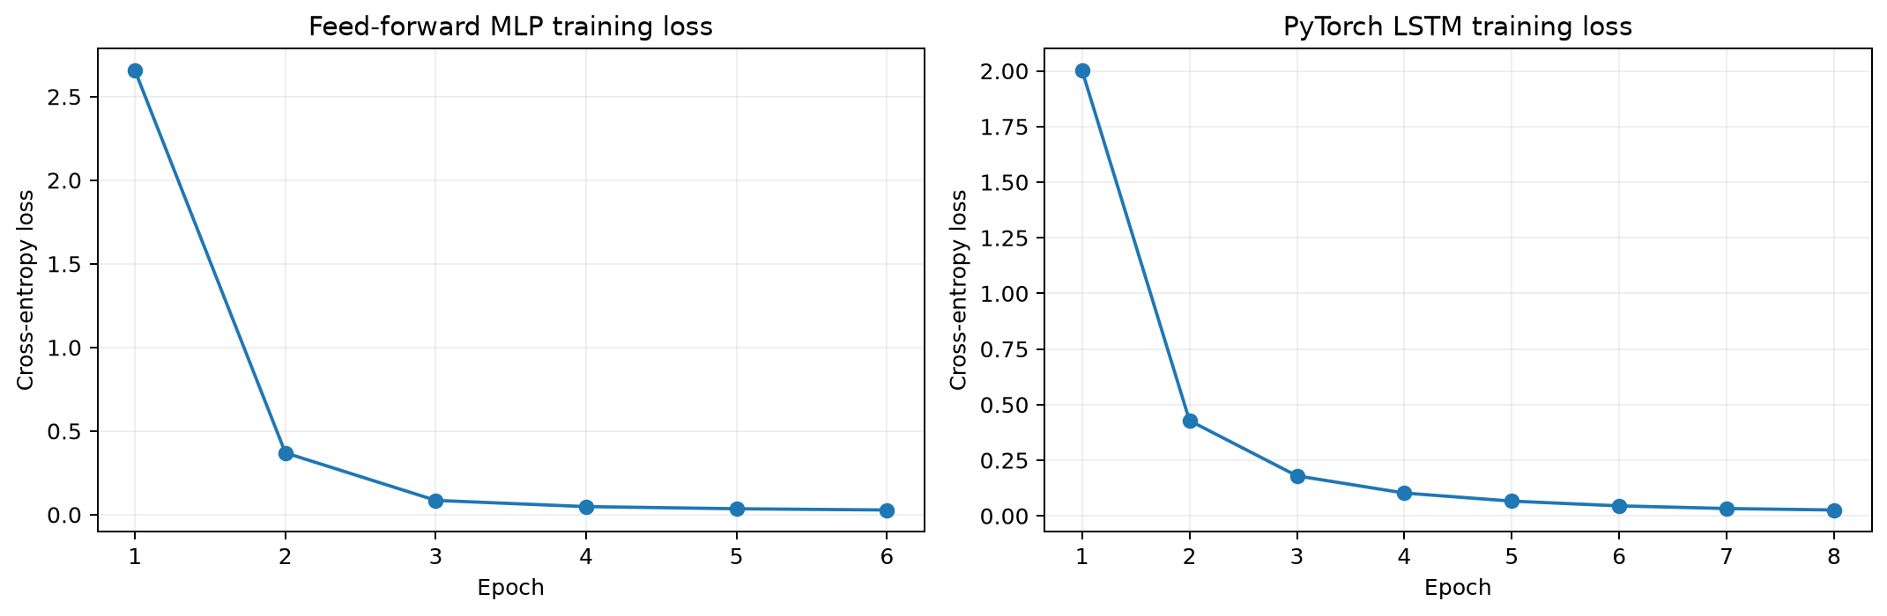
Figure 3. Training loss and validation macro F1 histories
Note. Saved Assignment 6 plot. The MLP and LSTM use different representations and have different epoch counts; the plotted histories show their own training/validation trajectories and should not be treated as a compute-time comparison.
Both models reached high validation macro F1. On the held-out test set, each scored slightly below its own best validation macro F1. The observed gaps are small, but a single split on synthetic/template-like data cannot rule out overfitting to dataset-specific lexical patterns.

10. Critical Code Snippets and Explanations
The excerpts below are selected from the executed Assignment 6 notebook; surrounding training boilerplate is omitted. They are intended to explain the design decisions rather than reproduce the complete source.

10.1 Normalize duplicates and validate group labels
normalized_instructions = (
df["instruction"].astype(str).str.casefold().str.replace(r"\s+", " ", regex=True).str.strip()
)
instruction_groups, unique_instructions = pd.factorize(normalized_instructions, sort=False)
group_summary = (
df.assign(instruction_group=instruction_groups)
.groupby("instruction_group", sort=False)
.agg(intent=("intent", "first"), label_count=("intent", "nunique"), rows=("intent", "size"))
)
if (group_summary["label_count"] != 1).any():
raise ValueError("A normalized customer instruction maps to multiple intent labels.")
duplicate_group_counts = (
group_summary.loc[group_summary["rows"] > 1]
.groupby("intent")
.size()
.reindex(label_counts.index, fill_value=0)
)
Source: week6_customer_support_intent_classification.ipynb, EDA/preparation cell
The same normalization defines duplicate groups. Aggregating each group and checking `label_count` prevents a normalized instruction with conflicting labels from being silently assigned to a split.

10.2 Stratify unique groups, then map groups to rows
all_group_ids = np.arange(len(unique_instructions))
train_groups, holdout_groups = train_test_split(
all_group_ids, test_size=0.30, random_state=SEED, stratify=group_y
)
valid_groups, test_groups = train_test_split(
holdout_groups, test_size=0.50, random_state=SEED, stratify=group_y[holdout_groups]
)
train_idx = np.flatnonzero(np.isin(instruction_groups, train_groups))
valid_idx = np.flatnonzero(np.isin(instruction_groups, valid_groups))
test_idx = np.flatnonzero(np.isin(instruction_groups, test_groups))
Source: week6_customer_support_intent_classification.ipynb, split cell
The code splits group IDs, not row indices, and then maps all rows from each group to a single partition. The assertions immediately following this excerpt verify partition disjointness and that every class appears in each split.

10.3 Fit text representation on training data only
vectorizer = TfidfVectorizer(
lowercase=True, ngram_range=(1, 2), max_features=12_000,
min_df=2, sublinear_tf=True, dtype=np.float32
)
X_train_tfidf = vectorizer.fit_transform(texts[train_idx])
X_valid_tfidf = vectorizer.transform(texts[valid_idx])
X_test_tfidf = vectorizer.transform(texts[test_idx])
Source: week6_customer_support_intent_classification.ipynb, MLP cell
`fit_transform` learns vocabulary and inverse-document-frequency statistics from training text; validation and test use `transform` so their content does not fit the representation.

10.4 Feed-forward neural architecture
class SparseTextMLP(nn.Module):
def __init__(self, input_size, number_of_classes):
super().__init__()
self.network = nn.Sequential(
nn.Linear(input_size, 256), nn.ReLU(), nn.Dropout(0.35),
nn.Linear(256, 128), nn.ReLU(), nn.Dropout(0.25),
nn.Linear(128, number_of_classes),
)
def forward(self, features):
return self.network(features)
Source: week6_customer_support_intent_classification.ipynb, MLP cell
The MLP operates on TF-IDF features through two ReLU/dropout hidden layers and returns one logit per intent.

10.5 Token-sequence LSTM architecture
class IntentLSTM(nn.Module):
def __init__(self, vocab_size, number_of_classes, embedding_size=64, hidden_size=64):
super().__init__()
self.embedding = nn.Embedding(vocab_size, embedding_size, padding_idx=0)
self.lstm = nn.LSTM(embedding_size, hidden_size, batch_first=True)
self.dropout = nn.Dropout(0.30)
self.output = nn.Linear(hidden_size, number_of_classes)
def forward(self, token_ids, lengths):
embedded = self.embedding(token_ids)
packed = pack_padded_sequence(
embedded, lengths.cpu(), batch_first=True, enforce_sorted=False
)
_, (hidden, _) = self.lstm(packed)
return self.output(self.dropout(hidden[-1]))
Source: week6_customer_support_intent_classification.ipynb, LSTM cell
The embedding converts token IDs to vectors. Packed sequences avoid treating padding as meaningful input; the final hidden representation is passed through dropout and a 27-class linear layer.

10.6 Multiclass metrics
def score_model(name, y_true, probabilities):
predictions = probabilities.argmax(axis=1)
return {
"model": name,
"accuracy": float(accuracy_score(y_true, predictions)),
"precision_macro": float(precision_score(y_true, predictions, average="macro", zero_division=0)),
"recall_macro": float(recall_score(y_true, predictions, average="macro", zero_division=0)),
"f1_macro": float(f1_score(y_true, predictions, average="macro", zero_division=0)),
"roc_auc_ovr_macro": float(roc_auc_score(y_true, probabilities, multi_class="ovr", average="macro")),
}
Source: week6_customer_support_intent_classification.ipynb, evaluation cell
Macro averaging gives each intent equal weight. The code computes multiclass one-vs-rest macro ROC-AUC from class probabilities; the ROC chart uses a separately flattened micro-averaged construction, as noted in the figure caption (scikit-learn developers, n.d.).

11. Experimental Setup and Evaluation Metrics
Experiments use random seed 42. The recorded environment reports PyTorch 2.14.1+cpu on CPU. The notebook uses scikit-learn for TF-IDF, label encoding, split generation, classification metrics, and ROC calculations; PyTorch provides the neural architectures and training loops. Reproducibility is supported by a fixed seed and saved split/result artifacts, although exact training determinism can still depend on package versions and hardware.
Metric | Interpretation in this task
Accuracy | Share of test requests assigned the correct intent.
Macro precision | Unweighted mean of per-intent precision; penalizes false routing per class equally.
Macro recall | Unweighted mean of per-intent recall; shows class-balanced coverage.
Macro F1 | Unweighted mean of per-intent F1; primary validation checkpoint/selection measure.
ROC-AUC (OvR macro) | Mean one-vs-rest ranking AUC across 27 classes using class probabilities; threshold-independent.
Confusion matrix | Actual intent by predicted intent; saved plot is normalized by actual class (row-wise).

Validation macro F1 was used to retain model checkpoints. The test partition was evaluated after model selection and reports the primary held-out comparison. ROC-AUC applies to probability scores; the hard-label majority baseline has no meaningful AUC here and is stored as not calculated.

12. Results, Tables, and Visual Evidence
The table below contains the saved test-set metrics. Values are read directly from `outputs/week6_results.json`; no metrics were re-estimated for this report.
Model | Accuracy | Macro precision | Macro recall | Macro F1 | OvR macro AUC
Majority baseline | 0.0335 | 0.0012 | 0.0370 | 0.0024 | Not calculated
Feed-forward MLP | 0.9921 | 0.9922 | 0.9922 | 0.9921 | 0.99996
PyTorch LSTM | 0.9883 | 0.9885 | 0.9883 | 0.9883 | 0.99991

Held-out test-set performance (n = 4,031).
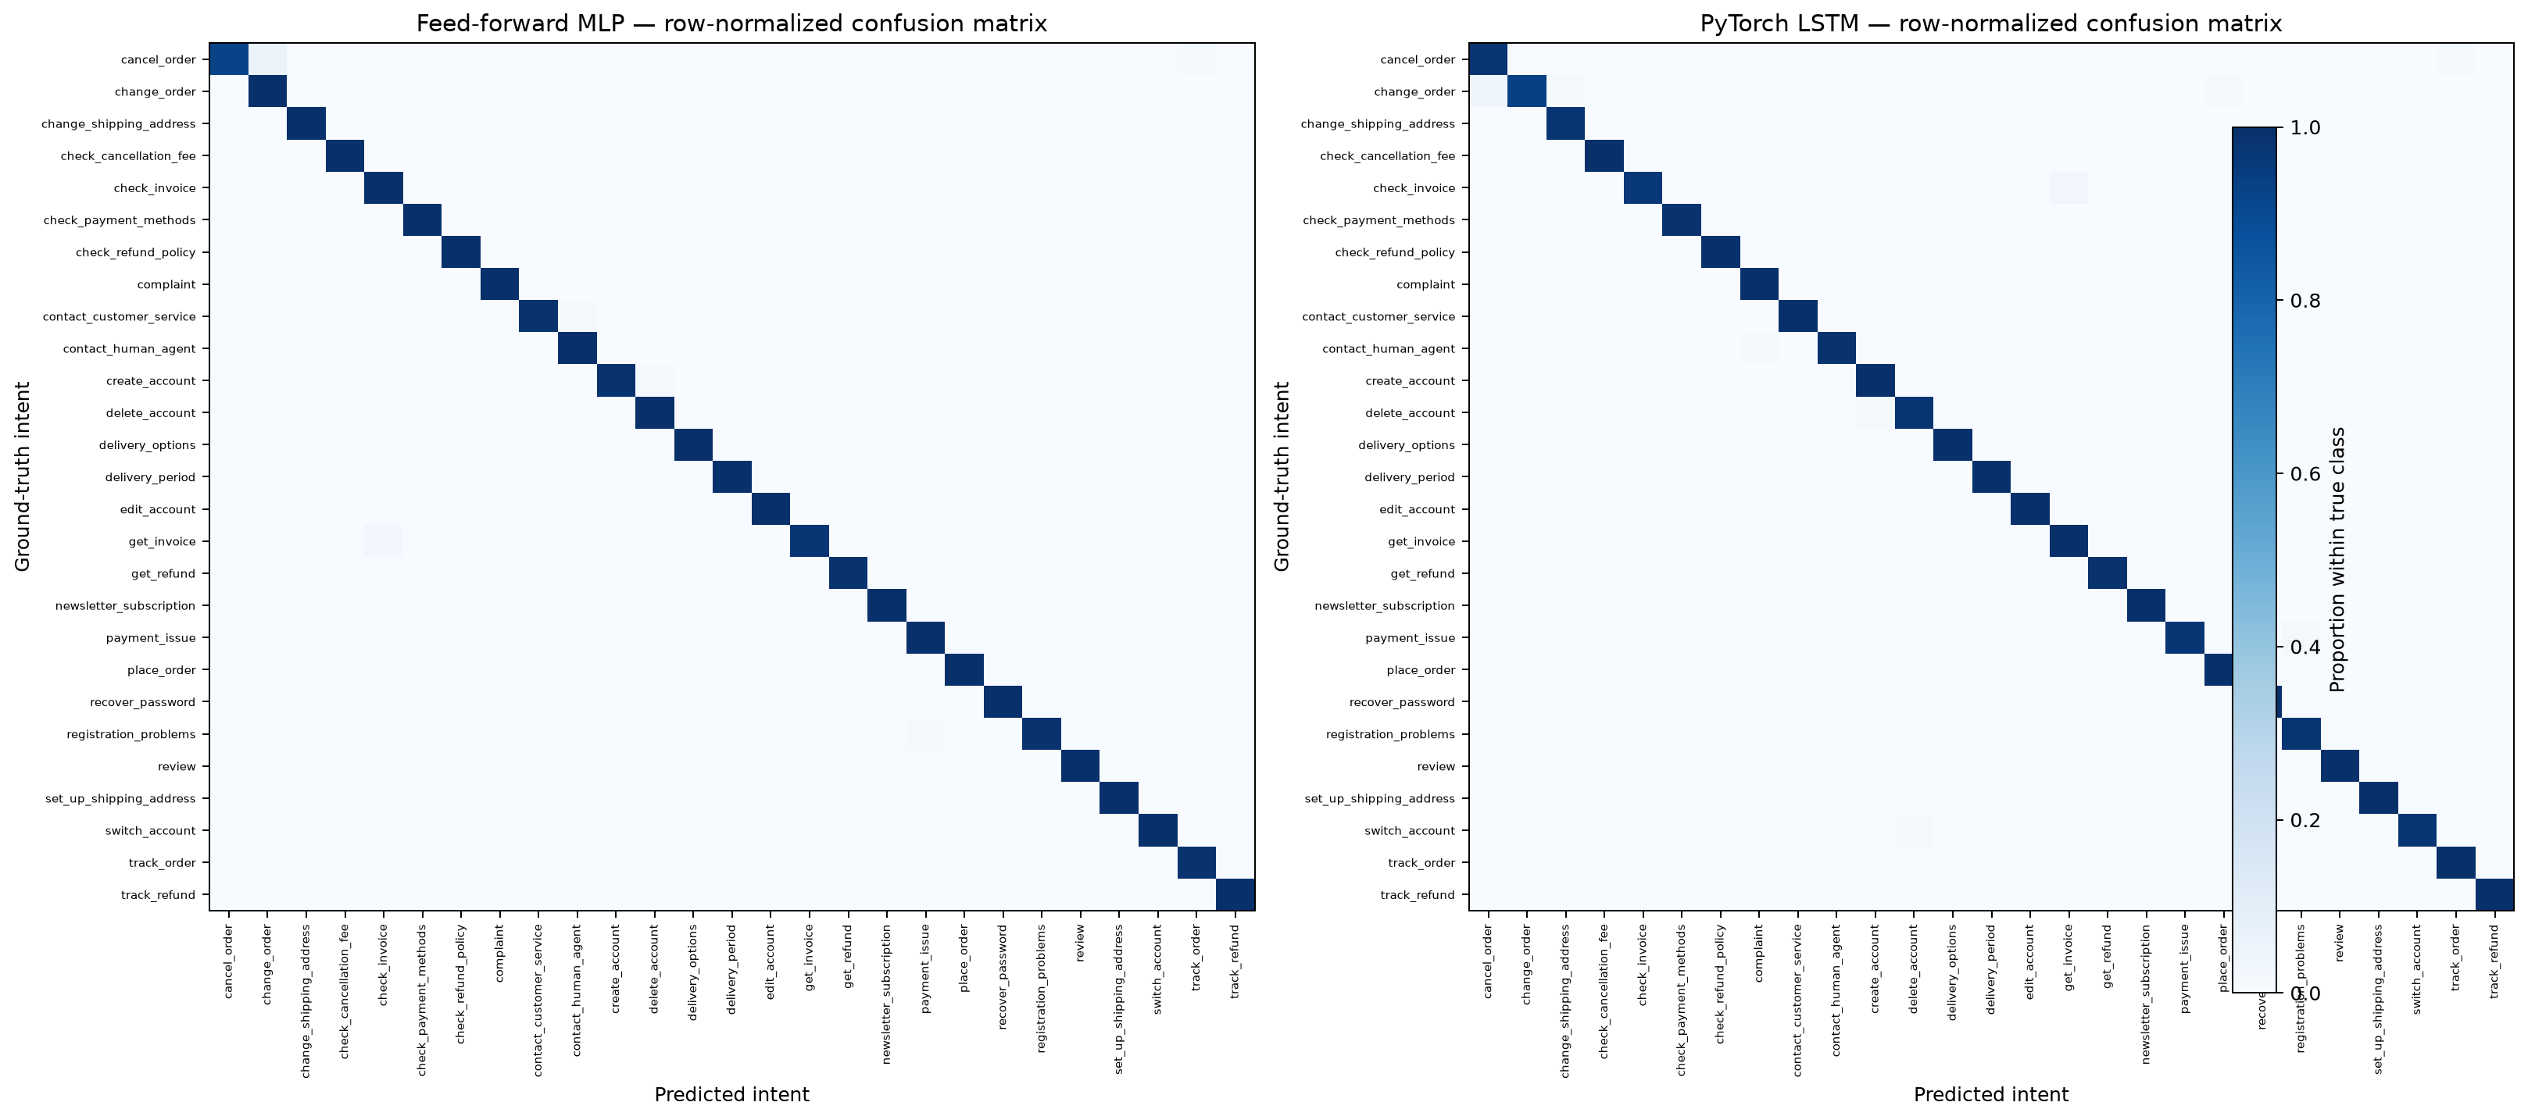
Figure 4. Held-out row-normalized confusion matrices for the MLP and LSTM
Note. Rows are ground-truth intents and columns are predictions; each row sums to one. The MLP has 3,999 correct predictions and 32 errors; the LSTM has 3,984 correct predictions and 47 errors. The full integer matrices are saved in the JSON results.
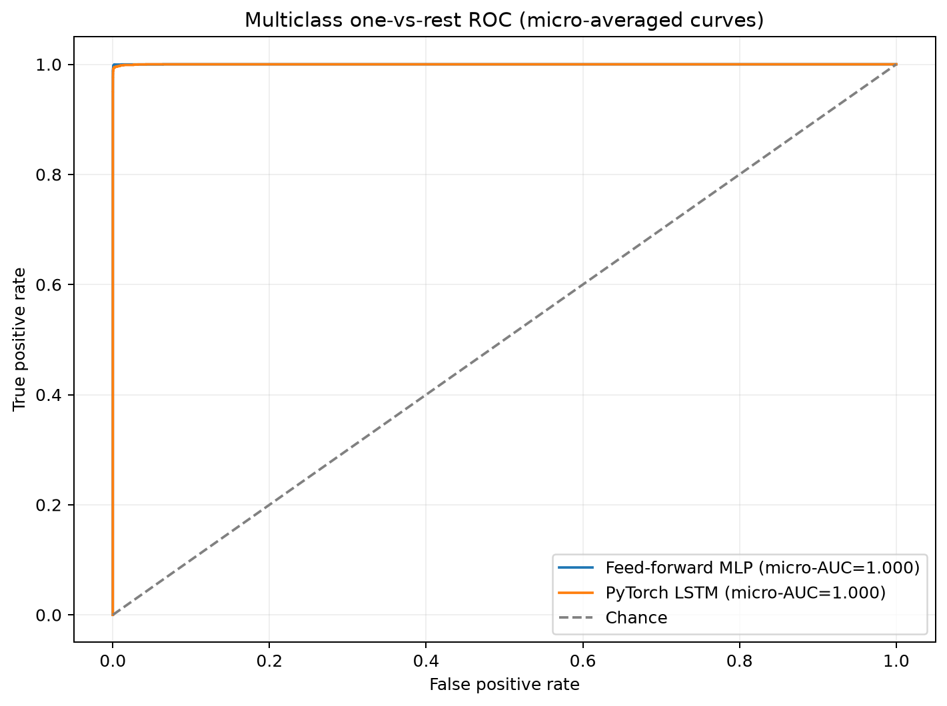
Figure 5. Held-out micro-averaged one-vs-rest ROC curves
Note. The notebook flattens the binarized labels and class probabilities and plots micro-AUC. The table reports the separate macro one-vs-rest AUC values: 0.99996 for the MLP and 0.99991 for the LSTM. Do not label this plotted micro curve as macro-averaged.
The requested screenshots were not present as separate screenshot files in the provided project artifacts. Figures 1, 3, 4, and 5 are genuine saved charts generated by the executed notebook—not screenshots of a user interface. Capture any additional notebook or editor screenshots directly from the executed project before submission; do not present the pipeline diagram as experimental output.
Suggested screenshot filename | Capture from the executed project | Evidence to show
assignment6_dataset_eda.png | Notebook EDA cells and saved EDA plot | 26,872 x 5 rows, 27 intents, missingness/duplicate audit, class counts.
assignment6_group_split.png | Notebook group-splitting cell output | Seeded train/validation/test row and group counts with disjointness assertions.
assignment6_model_training.png | Notebook training histories and selected checkpoints | MLP and LSTM train/validation macro-F1 history and selected epochs.
assignment6_final_test_results.png | Notebook evaluation cell and result table | Accuracy, macro P/R/F1, macro OvR AUC, per-intent results, confusion matrices, and ROC figure.

These are capture recommendations only; they are not embedded or claimed as existing screenshots. Use screenshots of the actual executed notebook, keep the metric names and class labels visible, and do not edit numerical results.

13. Comparative Performance Analysis
The MLP exceeds the LSTM by 0.372 percentage points in accuracy and 0.377 percentage points in macro F1, with 15 additional correct assignments on the same 4,031 test rows. Its macro one-vs-rest AUC advantage is 0.00005. Both models substantially exceed the 3.35% majority-baseline accuracy. The MLP is the stronger measured model on this test split, but the metric differences are small; the evidence does not establish a statistically significant or deployment-level advantage.
The observed outcome is consistent with the TF-IDF MLP being well matched to this corpus: unigrams and bigrams can encode distinctive intent phrases, while the task contains short, formulaic, automatically labeled requests. This is a plausible explanation, not a tested causal result. The LSTM's ability to model word order did not improve aggregate performance on this test partition; the MLP uses sparse TF-IDF and smaller batchwise dense conversion, while the LSTM uses train-derived token embeddings and sequence recurrent computation. Runtime, memory, and throughput were not measured, so computational cost cannot be ranked from the available evidence. This does not imply sequence models are generally inferior.
Intent | n | MLP P | MLP R | MLP F1 | LSTM P | LSTM R | LSTM F1
cancel_order | 158 | 0.9865 | 0.9241 | 0.9542 | 0.9627 | 0.9810 | 0.9718
change_order | 151 | 0.9379 | 1.0000 | 0.9679 | 0.9860 | 0.9338 | 0.9592
check_invoice | 144 | 0.9662 | 0.9931 | 0.9795 | 0.9858 | 0.9653 | 0.9754
get_invoice | 147 | 0.9931 | 0.9728 | 0.9828 | 0.9605 | 0.9932 | 0.9766

Per-intent values show that aggregate differences do not favor one architecture uniformly: the MLP has higher F1 for `change_order` and `check_invoice`, while the LSTM has higher F1 for `cancel_order` and `get_invoice`. These are observed class-level differences in this test set, not evidence of stable class-specific superiority.
Validation-best macro F1 was 0.9943 for the MLP and 0.9918 for the LSTM; corresponding test scores are 0.9921 and 0.9883. The validation-to-test gaps are 0.0022 and 0.0034. These small gaps are observed. They do not rule out overfitting to synthetic templates or answer whether performance transfers to naturally occurring user requests.

14. Discussion of Limitations and Potential Improvements

Observed limitations
- The dataset card describes hybrid synthetic/automatically labeled content. High scores measure agreement with those labels on this corpus, not correctness for real customer intents or actual queue-routing benefit.
- The split prevents exact normalized duplicates from crossing partitions, but paraphrase/template overlap and near-duplicate semantics were not comprehensively measured.
- There is no external validation set, independently labeled human sample, prospective customer traffic, or operational routing outcome in this experiment.
- Each intent has relatively similar support (950–1,000 source rows), but similar counts do not guarantee equal linguistic coverage, label quality, or fairness across customer groups and writing styles.
- No demographic or protected-group attributes are part of the audited model input/results; fairness across such groups is therefore unmeasured, not proven.
- Training loss falls substantially while validation macro F1 improves. Validation-test differences are modest, but available artifacts do not contain a controlled learning-curve analysis sufficient to dismiss overfitting.
- The notebook ran on CPU and records no elapsed time, peak memory, energy use, or inference latency. Computational cost cannot be quantitatively compared from the available outputs.
- The ROC figure is micro-averaged whereas the headline scalar AUC is macro one-vs-rest. Both are valid summaries but answer different averaging questions and must be labeled distinctly.

Potential improvements
- Evaluate on a separately collected, human-labeled set of real customer messages, with clear privacy and consent controls.
- Add template-aware and semantic near-duplicate detection or hold out templates/sources to test lexical generalization beyond exact normalization.
- Report uncertainty with repeated seeded group splits or group-aware cross-validation, while keeping a final external test untouched.
- Inspect per-intent errors and confusion pairs with domain reviewers; improve ambiguous label definitions and assess annotation agreement.
- Measure calibration, selective prediction/abstention, and the impact of routing errors; a high macro F1 alone does not define a safe routing threshold.
- Benchmark wall-clock training, inference throughput, and memory with recorded hardware/software settings before making efficiency claims.
- Compare the current neural models with a simple TF-IDF linear classifier and a suitable pretrained text encoder only as future experiments, preserving the existing results as the baseline.
Potential causes above are labeled as explanations or recommendations. The report distinguishes them from the measured test metrics and notebook observations.

15. Conclusion
Assignment 6 implements a reproducible, duplicate-aware 27-class intent-classification experiment using a TF-IDF feed-forward MLP and a token-sequence LSTM. The 26,872-row Bitext corpus contains 27 near-balanced labels; the notebook normalizes and groups repeated requests, splits groups by intent, and learns text representations from training data only. On 4,031 held-out rows, the MLP achieved 0.9921 accuracy and 0.9921 macro F1, marginally exceeding the LSTM's 0.9883 accuracy and 0.9883 macro F1. Both substantially exceed the 0.0335 majority baseline on this dataset.
The results support the conclusion that both architectures fit the dataset's labeled intent patterns very well, with a small measured advantage for the MLP on this split. Because the source is hybrid synthetic and automatically labeled, exact duplicates are not the only possible source of similarity, and no real-customer or operational validation was performed, the results should be treated as a dataset-specific prototype rather than evidence of production readiness.

16. References
References below are limited to the dataset source, software documentation, and the project artifacts actually used. The dataset page does not identify a conventional journal publication for this CSV; no paper citation is inferred.
Bitext. (n.d.). Bitext—Customer service tagged training dataset for LLM-based virtual assistants [Data set]. Hugging Face. Retrieved October 18, 2026. https://huggingface.co/datasets/bitext/Bitext-customer-support-llm-chatbot-training-dataset
Bishwadeep Rai. (2026). Customer support intent classification: Assignment 6 executed notebook, saved results, and figures [Source code and data analysis]. GitHub. https://github.com/BishwadeepRai/Smart-queue-Time-Management-system
scikit-learn developers. (n.d.). TfidfVectorizer API reference. Retrieved October 18, 2026. https://scikit-learn.org/stable/modules/generated/sklearn.feature_extraction.text.TfidfVectorizer.html
scikit-learn developers. (n.d.). roc_auc_score API reference. Retrieved October 18, 2026. https://scikit-learn.org/stable/modules/generated/sklearn.metrics.roc_auc_score.html
PyTorch contributors. (n.d.). torch.nn.LSTM documentation. Retrieved October 18, 2026. https://pytorch.org/docs/stable/generated/torch.nn.LSTM.html
PyTorch contributors. (n.d.). torch.nn.Embedding documentation. Retrieved October 18, 2026. https://pytorch.org/docs/stable/generated/torch.nn.Embedding.html

17. GitHub Repository
The Assignment 6 notebook, report, output metrics, and supporting figures are maintained in the project repository:
https://github.com/BishwadeepRai/Smart-queue-Time-Management-system
Assignment 6 directory: week 6. The raw Bitext CSV is retrieved from its dataset source and cached locally; it is not represented as a tracked repository file.

